Camera: top down (perpendicular to board)
include entire scoring board + 1 foot margin,
if hard can be top + homographies
will make some fine tuning in the cv side through projection transformation,
match the corner of the board so that its smooth plane
Pros: Holes appear circular, paths are in 2d, Easy to define scoring zones

General structure
Define the hole and pedal polygon
Implement ball tracking, flame tracking
testing
Ball tracking
- Color-based tracking
HSV color space to segment the ball
HSV(Hue, Saturation, Value) separates color information from brightness,
much more robust to lighting changes than RGB

step1: Capture Sample Frames of the ball
step2: find the exact HSV values for the ball under specific lighting:
hsv = cv2.cvtColor(image, cv2.COLOR_BGR2HSV)
step3: set a Common Ball Color Ranges
lower_orange = np.array([10, 100, 100])
upper_orange = np.array([25, 255, 255])
Apply morphological operations to clean noise
process images based on shapes by sliding kernel(filter) across the image
erosion: remove noises, separate touching objects, shrink boundaries
dilation: fills gaps, connect nearby region grow boundaries
e.g eroded = cv2.erode(mask, kernel, iterations=1)
opened = cv2.dilate(eroded, kernel, iterations=1)
or cv2.morphologyEx(mask, cv2.MORPH_OPEN, kernel)
cv2.morphologyEx(mask, cv2.MORPH_CLOSE, kernel)
option: use gaussian blur to smooth edges
Track centroid position frame-to-frame
Find contors of the ball using
cv2.findContours(img, cv2.RETR_EXTERNAL, cv2.CHAIN_APPROX_SIMPLE)
find cv2.moments and extract center of mass

implement tracker (multiball tracker)

While video is running:
1. Capture new frame
2. Detect ball → get centroid
3. Add centroid to trajectory list
4. Calculate velocity from last two positions
5. Draw trajectory on screen
6. Check if ball entered any scoring zone

- Background subtraction
Create a background model of empty board
Detect the moving object new frame – background = object

cv2.createBackgroundSubtractorMOG2
Hole detection. Pedal detection (Region of Interest)
scoring_zones = {
'hole_100': {
'center': (320, 400),
'radius': 30, # pixels
'points': 100
},
'hole_50': {
'center': (280, 420),
'radius': 25,
'points': 50
}
} //array of holes, array of pedals

Detect score for hole and pedal
Use cv2.pointPolygonTest() check if a point is in the polygon or not
Or use a finding distance and see if its less than threshold (radius) FASTER
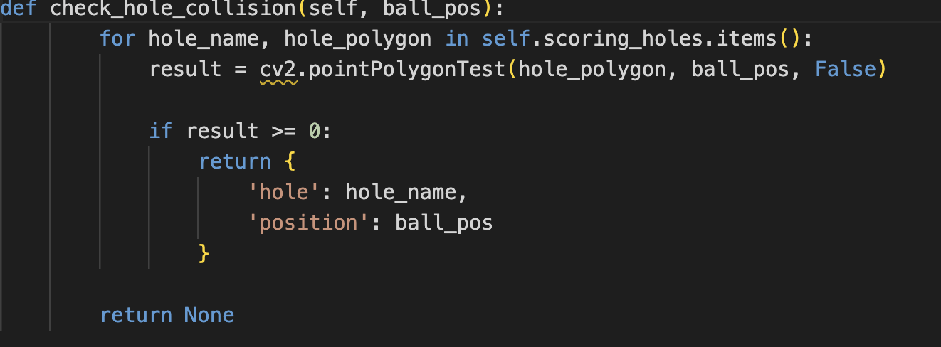

Flame detection
- Detect sudden appearance of bright pixels (flame) using threshold
- Physical sensor

Cload Integration
REST API for submit to database

